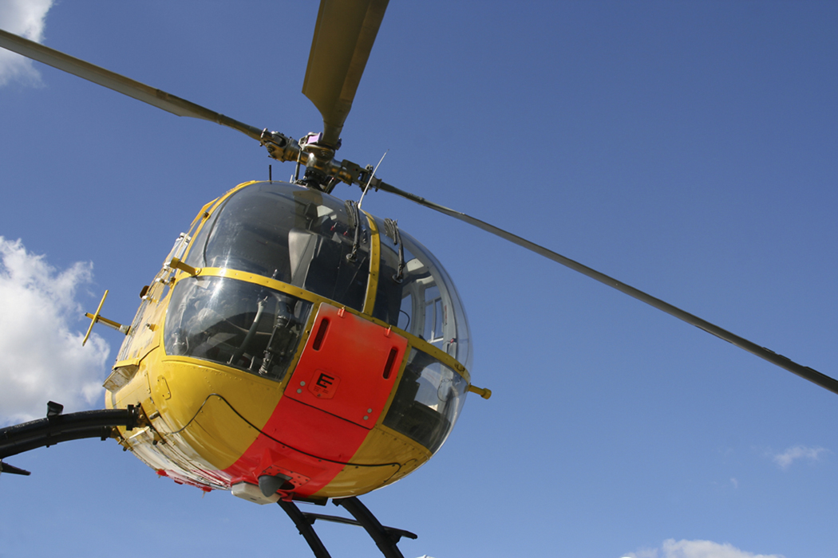

$5000 awarded to a student at Stroud high school.
Priority will be given to a graduating senior planning on pursuing a career in the field of aviation.
General Instructions: Answer all questions to the best of your ability and follow instructions completely.

Personal Data
Sex: O Male O Female

First Name: __________________________ Last Name: ________________________

Home Address: ___________________________________________________________

Telephone: ___________________________________

______________________________________________________________________________________

Academic Information
7 semester GPA: ___________________ 7 semester class rank: ________________________

ACT Score: ______________________
______________________________________________________________________________________

Leadership Activities/Organizations

Activities |  | 9th Grade | 10th Grade | 11th Grade | 12th Grade | Title or Office held
A.. | Student Council
B. | Class Officer
D. | Newspaper
E. | National Honor Society
F. | Yearbook

School Activities (Sports, band, choir, FFA, etc)

Activity | 9th Grade | 10th Grade | 11th Grade | 12th Grade | Lettered / Captain
___________________________________________________________________________________

Special Recognition, Awards, Honors, etc.
Special Recognition Awards, Honors, etc.

____________________________________________ ___________________________________________________

____________________________________________ ___________________________________________________

____________________________________________ ___________________________________________________

____________________________________________ ___________________________________________________

____________________________________________ ___________________________________________________

____________________________________________ ___________________________________________________

Community Service & Volunteerism

Service Project Description 9 10 11 12 Estimated # of hours

______________________________________________________ __ __ __ __ ______________

______________________________________________________ __ __ __ __ ______________

______________________________________________________ __ __ __ __ ______________

______________________________________________________ __ __ __ __ ______________

______________________________________________________ __ __ __ __ ______________

______________________________________________________ __ __ __ __ ______________

Work Experience

Employment Description Estimated # of Hours Weekly

_______________________________________________________________________ ______________

_______________________________________________________________________ ______________

_______________________________________________________________________ ______________

_______________________________________________________________________ ______________

_______________________________________________________________________ ______________

Career Plans
Please give a brief statement of your career plans after graduation. Include your higher education plans as well as intended major.

_____________________________________________________________________________________________________

_____________________________________________________________________________________________________

_____________________________________________________________________________________________________

_____________________________________________________________________________________________________

_____________________________________________________________________________________________________

_____________________________________________________________________________________________________

_____________________________________________________________________________________________________

_____________________________________________________________________________________________________

_____________________________________________________________________________________________________

_____________________________________________________________________________________________________

To receive scholarship money proof of enrollment at a college, university, or technical school must be provided. Contact person will be high school principal.

Deadline: April 1st . Return to Mrs. Elerick

